Breadth-First Search (BFS)
AIM:
To write a Python program to implement Breadth-First Search for graph traversal.

ALGORITHMS:
- Start.
- Initialize an empty visited set and a queue containing the starting node.
- Remove the first node from the queue.
- If the node is not visited, mark it as visited and print it.
- Add all unvisited neighboring nodes to the queue.
- Repeat steps 3–5 until the queue is empty.
- Stop.

CODE:
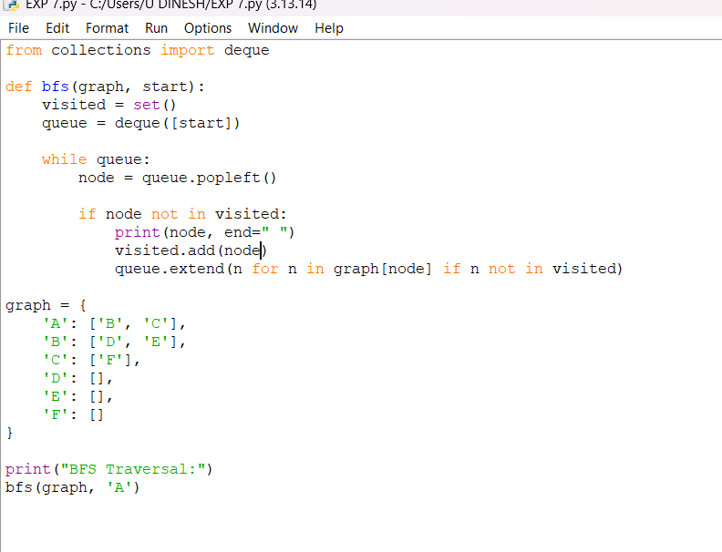
OUTPUT:
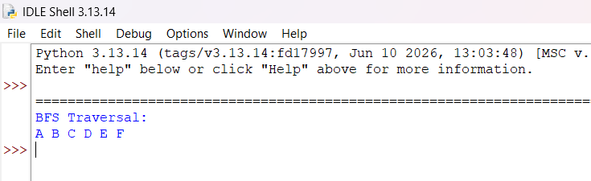
RESULT:
Breadth-First Search (BFS): The graph is traversed level by level

